Part A

Table of Contents
Introduction 3
Security Risks of the Domain 3
Broken Object Level Authorization (BOLA) 3
Broken Authentication and JWT Handling Risks 4
Injection Attacks (SQL Injection and Data Injection) 4
Excessive Data Exposure and Debug Endpoints 5
Mass Assignment 5
Lack of Resources and Rate Limiting (DoS Risk) 5
Operational Impact 6
Analyzing Design Risks (Threat Modeling) 6
Authentication and Authorization 6
Communication and Protocol 7
Session and State Management 7
Input Validation Failure 7
Threat Modeling using STRIDE 8
Static Code Analysis 9
Methodology 9
Automated Scan Results (Bandit) 9
Manual Review Results (Verified Vulnerability Paths) 9
Interpretation 10

Introduction
VAmPI (Vulnerable API) is an intentionally vulnerable REST API implemented in Python using Flask and OpenAPI 3 specifications. The project was created for learning and for evaluating the effectiveness of security tools against realistic API vulnerability patterns. It includes the switch that enables a vulnerable mode and a secure mode, allowing control comparison findings and false positives/negatives during testing. Functionally, VAmPI models are small book service. Unregistered users can retrieve the limited information, while registered users authenticate via token-based authentication (JWT) to add books containing a title and a secret, where the secret should only be accessible by the owner. The API exposes its contract through Swagger UI and an OpenAPI specification, enabling direct, interaction and structured testing.
Code size note: We measured approximately 500 LOC (excluding dependencies and artifacts) using cloc.

Security Risks of the Domain
Because VAmPI is an API-first service (no traditional browser UI) its risk profile is dominated by common API security failures: authorization at object level, token handling mistakes, excessive exposure of data, injection into backend queries, and missing resource protections like rate limiting. The VAmPI project explicitly includes several OWASP top 10 style weaknesses by design, which makes it suitable for structured security analysis.

Broken Object Level Authorization (BOLA)
BOLA occurs when an API accepts an object identifier but does not reliably validate that the authenticated user is authorized to access the specific object. This is consistently one of the most common and severe API risks. In VAmPI, the domain design includes endpoints that fetch object specific data. If authorization checks are incomplete or implemented inconsistently, an attacker can pivot from one valid token to unauthorized access of other users’ objects.

Mitigations:
- Enforce authorization checks on every object access (server-side, client-side)
- Use deny-by-default patterns and centralized authorization helpers.
- Avoid predictable object identifiers or ensure authorization is independent of ID predictability.

Broken Authentication and JWT Handling Risks
Modern APIs often rely on stateless tokens (JWT). JWTs are compact tokens that represent claims, typically integrity-protected using signatures. If the key is weak, leaked, or mismanaged, token forgery becomes possible which effectively collapses authentication and authorization controls. VAmPI includes “JWT authentication bypass via weak signing key” as part of its vulnerability set, making token security a central domain risk in its system.

Mitigations:
- Use strong secrets/ key management, rotate keys, and store keys securely.
- Prefer asymmetric signing (where appropriate) with managed key material.
- Validate algorithm, expiration, issuer/audience, and reject none/unexpected algorithms.
- Keep token lifetime short and enforce refresh/token revocation patterns where required.

Injection Attacks (SQL Injection and Data Injection)
Injection remains a high-impact risk for APIs, especially when user-controlled input reaches database queries without strict validation or parameterization. VAmPI includes SQL Injection as an intentional vulnerability. The operational impact ranges from unauthorized reads (data exposure) to data manipulation, privilege escalation, and potential service disruption.

Mitigations:
- Parameterized queries/ORM-safe query construction.
- Input validation at the boundary (schema validation with strict types/constraints).
- Least-privilege database accounts and query logging for anomaly detection.

Excessive Data Exposure and Debug Endpoints
A recurring real-world failure is leaving “debug” endpoints or overly verbose responses available in production. VAmPI includes a _debug endpoint that exposes full user details, and the project explicitly lists “Excessive Data Exposure through debug endpoint” as a vulnerability. This type of exposure can directly enable account compromise, credential stuffing, and privilege escalation.

Mitigations:
- Remove debug endpoints from production builds.
- Apply authorization to any administrative/diagnostic endpoints.
- Apply “minimum necessary data” response design (data shaping, DTOs, field allowlists).

Mass Assignment
Mass assignment issues occur when the API binds user input directly into backend objects/models, unintentionally allowing modification of sensitive fields (e.g., admin=true). VAmPI includes mass assignment as a deliberate weakness, and it is commonly discussed as a core API security risk.

Mitigations:
- Explicit allowlists for writable properties.
- Separate request models from persistence models.
- Validate input against strict schemas that exclude sensitive fields.

Lack of Resources and Rate Limiting (DoS Risk)
Without rate limiting, an API is exposed to brute-force attempts, token flooding, and resource exhaustion (including computational DoS patterns such as RegexDoS). VAmPI explicitly includes “Lack of Resources & Rate Limiting” and “RegexDOS” as vulnerabilities. OWASP also highlights rate limiting/resource controls as key defenses against abuse.

Mitigations:
- Rate limiting per IP / per token / per route (tiered limits).
- Timeouts, request size limits, concurrency limits, and circuit breakers.
- Safe regex practices and input length caps.

Operational Impact
In a realistic deployment, the risks above can cause:
- Confidentiality loss: credential leakage, user data exposure, private “book secrets” disclosure.
- Integrity compromise: unauthorized password/email changes, admin flag manipulation, object tampering.
- Availability reduction: brute-force, regex/resource exhaustion, and request floods.

Analyzing Design Risks (Threat Modeling)
VAmPI’s architecture can be summarized as:
- Clients: Swagger UI / Postman / scripts
- API Layer: Flask + OpenAPI routing (request parsing, auth checks)
- Auth: JWT bearer tokens
- Data Store: SQLite via application persistence layer (as implemented by the project)
- Trust boundaries: Client ↔ API (untrusted network boundary), API ↔ DB (internal boundary)
VAmPI’s published endpoint set (e.g., /users/v1/*, /books/v1/*, /me, /createdb) provides clear attack surfaces for both authenticated and unauthenticated flows.

Authentication and Authorization
Key design risks include:
- Tokens that can be forged/abused if signing keys or validation are weak.
- Missing object-level authorization checks leading to BOLA-style access

Mitigations:
- Harden JWT validation and key management (server-side)
- Centralize authorization decisions and verify object ownership/roles per request.

Communication and Protocol
While the lab is typically run locally, a real deployment would require TLS to protect tokens and credentials in transit and prevent MITM capture.

Mitigations:
- Enforce HTTPS everywhere, reject insecure transport for authenticated routes.
- Apply security headers and robust CORS policy (least privilege).

Session and State Management
JWTs are stateless; therefore, token TTL, rotation, and invalidation strategy matter. VAmPI allows token lifetime configuration, which is useful for demonstrating how token TTL affects exposure windows.

Mitigations:
- Short TTL + refresh strategy, rotate tokens on privilege changes.
- Server-side deny lists for compromised tokens where needed.

Input Validation Failure
Many VAmPI weaknesses are consequences of insufficient validation:
- SQLi risks when unsafe query construction occurs
- RegexDoS / resource exhaustion from unbounded or unsafe patterns.
- Mass assignment when object binding is too permissive.

Mitigations:
- Strict schema validation (type/length/format).
- Allowlists for writable fields
- Defensive programming around regex and expensive operations.

Threat Modeling using STRIDE
STRIDE provides a structured way to map threats to controls.

Spoofing: Token forgery or credential harvesting (especially if debug exposure assists).
Mitigation: hardened authentication, MFA where applicable, strong JWT signing and validation.

Tampering: Unauthorized changes to user email/password or object data due to weak authorization checks.
Mitigation: object-level authorization, integrity controls, strict role enforcement.

Repudiation: Limited/no audit logging makes it difficult to attribute actions (e.g., user deletion).
Mitigation: append-only logging, request IDs, timestamps, and tamper-evident log storage.

Information Disclosure: _debug endpoint and overly verbose responses can leak credentials and sensitive fields.
Mitigation: remove debug endpoints, minimize response fields, enforce access controls.

Denial of Service: Lack of rate limiting and RegexDoS-style patterns allow resource exhaustion.
Mitigation: rate limiting, request caps, safe regex, timeouts.

Elevation of Privilege: Mass assignment enabling admin or token forgery enabling elevated roles.
Mitigation: field allowlists, role validation server-side, hardened token verification.

Static Code Analysis

Methodology
To assess the security posture of VAmPI (Vulnerable API), we conducted a static analysis using a two-layer approach. First, we cloned the project from GitHub and ran Bandit, a Python security linter, to identify common insecure coding patterns. Second, we performed a targeted manual code review of the API routes and model logic to verify intentionally vulnerable code paths and to map findings to common API vulnerability categories.

Automated Scan Results (Bandit)
Bandit reported 6 total issues:
- Medium severity (2):
  - SQL injection pattern (string interpolation in query construction)
  - Binding to all interfaces (service exposure risk when combined with debug mode)
- Low severity (4):
  - Hardcoded secret material
  - Insecure randomness
  - Additional low-severity items including benign/false-positive patterns (depending on the exact finding context)
These results highlight both code-level risks (e.g., unsafe query construction) and operational exposure risks (e.g., network binding).

Manual Review Results (Verified Vulnerability Paths)
Manual inspection identified two classes of weaknesses:
- Intentional vulnerabilities (controlled by the vuln flag): 9
These are implemented to demonstrate insecure patterns in a controlled way, including:
- SQL Injection
- Unauthorized Password Change
- Broken Object Level Authorization (BOLA)
- Mass Assignment (privilege escalation via request fields)
- User/Password Enumeration
- Regex DoS (catastrophic backtracking risk)

- Always-present weaknesses (not controlled by the vuln flag): 2+
These weaknesses remain active regardless of the intentional-vulnerability toggle:
- Debug endpoint exposing user credentials (including passwords)
- Weak JWT signing secret ('random') enabling token forgery risk
- Additional always-on security gaps were also observed:
- No password hashing (plaintext storage)
- No rate limiting (abuse and brute-force exposure across endpoints)

Interpretation
Overall, the findings confirm that VAmPI is structured specifically to demonstrate API security failures. The most important distinction is that some vulnerabilities are scenario-controlled (via vuln), while several weaknesses are baseline unsafe defaults (debug exposure, weak JWT secret, lack of hashing, lack of throttling). In a real deployment, the always-present issues would be treated as critical because they enable immediate compromise even without advanced exploitation.

Appendix
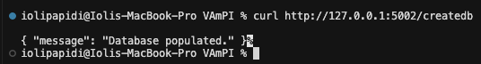
Figure 1: Database initialized successfully. Default users created.
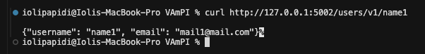

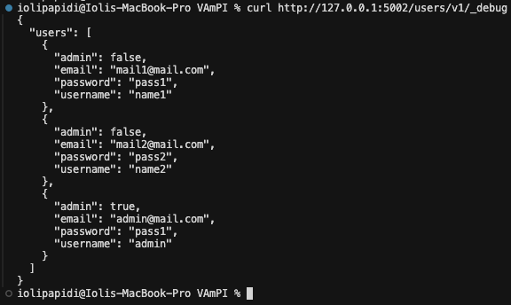
Figure 2: passwords exposed due to excessive data exposure (debug endpoint)

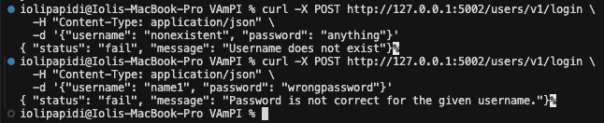
Figure 3: User enumeration confirmed. Different error messages reveal username existence.

Figure 4: successful login with token

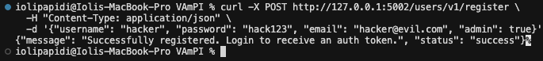
Figure 5: Register user with admin flag

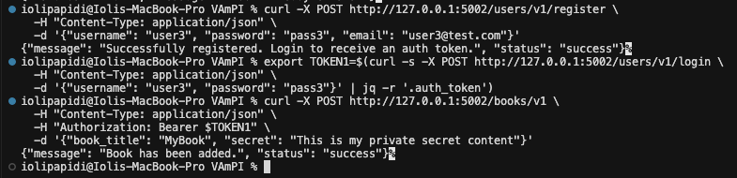
Figure 6: Create a non-authenticated user and create a secret book

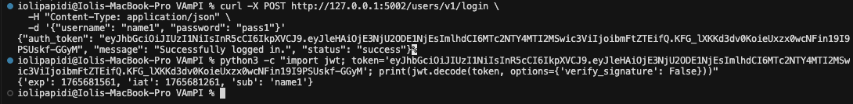
Figure 7: Capture JWT token and decode

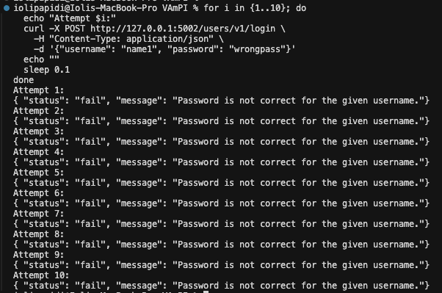
Figure 8: No rate limiting thus allowing consecutive login attempts

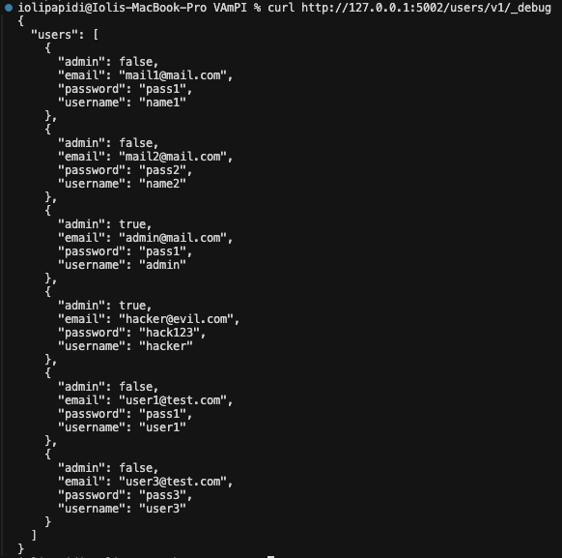
Figure 9: Password storing in plaintext

